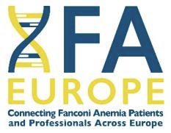

**Fanconi Anemia Virtual Tumor Advisory Board**

I consent to my pseudonymised medical data being presented at the Virtual Tumor Advisory Board organised by FA Europe. The tumor board will be conducted as a video conference, with physicians from across Europe participating.

This consent applies to all subsequent tumor board meetings. You may revoke your consent at any time without providing any reason.

yes  no

____________________________________________

date, signature